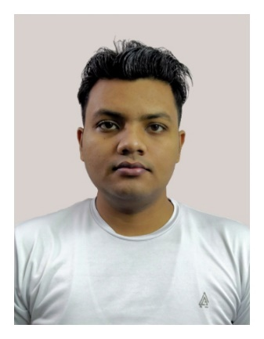

|  |
| --- |
| CONTACT ME |

 Faridabad, Haryana, India

ssjshivam2777@gmail.com



 +91 7703903587

[https://www.linkedin.com/in/ssjshivam](https://www.linkedin.com/in/ssjshivam/)



|  |
| --- |
| EDUCATION |

* **Graduation**

Bachelor of Commerce with  
University of Delhi, **7.47 CGPA**, 2021

* **High School**

Central Board of Secondary Education, New Delhi, **81%**, 2018

|  |
| --- |
| SOFT SKILLS |

ADAPTABILITY

ATTENTIVE

COOPERATIVE

INQUSITIVE

SURYA PRATAP SINGH

|  |
| --- |
| OBJECTIVE |

To prove my flexible and compassionate characteristic towards the job. With the willingness to serve with dedication and commitment to the assigned work. To possess good work ethics and versatility in the working environment.

|  |
| --- |
| BASIC INFORMATION |

**Date of Birth:** 1st March 1999

**Marital Status:** Single

**Mother’s Name:** Smt Munni Devi

**Father’s Name:** Shri Shiv Prasad

**Language:** Hindi, English (intermediate)

|  |
| --- |
| CERTIFICATIONS |

**Udemy:** 100 Days of Code: The Complete Python Pro Bootcamp for 2023

**Typing.com:** Advance Assessment (44 WPM)

|  |
| --- |
| HARD SKILLS |

* **Programming Languages**
  + Python, HTML, CSS
* **Libraries & Frameworks**
  + Flask, Bootstrap, SQLalchemy
* **Office Tools**
  + MS Excel, MS Word, MS Power point,
* **Design**
  + Canva, Photoshop, GIMP
* **Other Tools**
  + Git, GitHub, Render